**Project Design Phase-II**

**Data Flow Diagram & User Stories**

|  |  |
| --- | --- |
| Project Name | AI-based Threat Intelligence Platform |

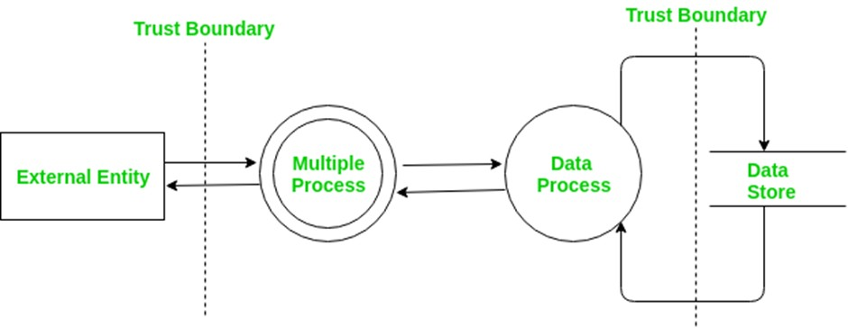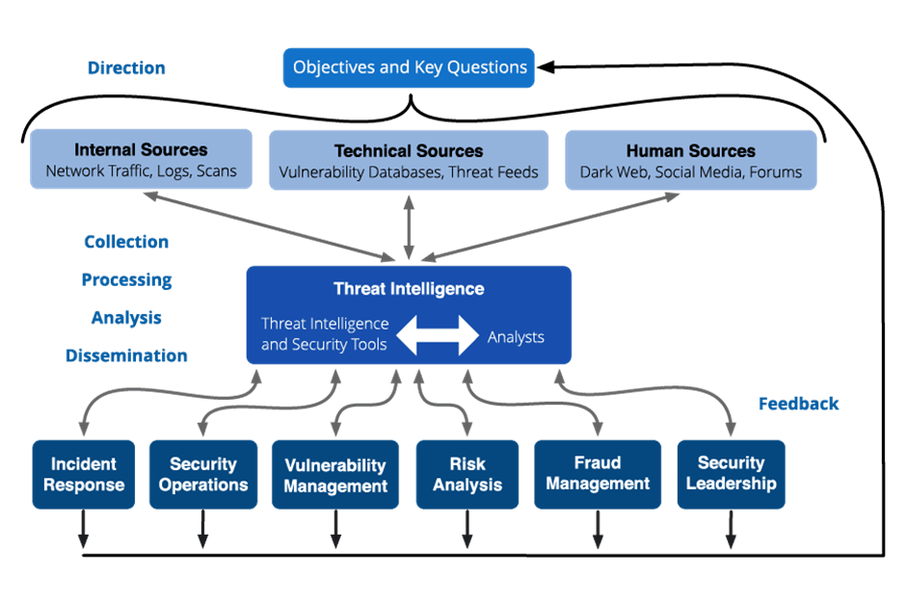

**User Stories**

|  |  |  |  |  |  |  |
| --- | --- | --- | --- | --- | --- | --- |
| **User Type** | **Functional Requireme**  **nt (Epic)** | **User Story Number** | **User Story / Task** | **Acceptance Criteria** | **Priority** | **Release** |
| **Customer**  **(Mobile User)** | **AI-based**  **Threat Intelligenc**  **e** | USN-  1 | As a user, I can register for the AI-based Threat Intelligence Platform by entering my email, password, and confirming my password. | I can access my AI-based threat intelligence dashboard | High | Sprint-1 |
| **Administrator** | **AI Model Configurat**  **ion** | USN-  16 | As an administrator, I can configure the AI models used for threat intelligence, specifying the sources and data parameters. | AI models are configured and operational | High | Sprint-2 |
| **Customer (Web User)** | **Real-time**  **Threat**  **Alerts** | USN-  17 | As a web user, I can receive realtime threat alerts on my dashboard based on AI analysis of incoming data. | I can see realtime threat alerts relevant to my account. | High | Sprint-3 |
| **Customer Care Executive** | **Incident Handling** | USN-  18 | As a customer care executive, I can view and respond to AI-generated incident reports and take appropriate action. | I can access incident reports and follow the prescribed action plan. | High | Sprint-3 |
| **Administrator** | **Data**  **Integration** | USN-  19 | As an administrator, I can integrate new data sources into the AI-based threat intelligence platform to enhance analysis. | New data sources are successfully integrated and contribute to threat analysis. | Medium | Sprint-4 |
| **Customer**  **(Mobile User)** | **Profile**  **Customiza**  **tion** | USN-  20 | As a user, I can customize my threat alert preferences and notification channels within the AI-based platform. | I receive threat alerts through my preferred channels and for the selected types of threats. | Medium | Sprint-2 |